Rev. Melanie B. Mullen

DIRECTOR, DEPARTMENT OF RECONCILIATION, JUSTICE, CREATION CARE, THE EPISCOPAL CHURCH
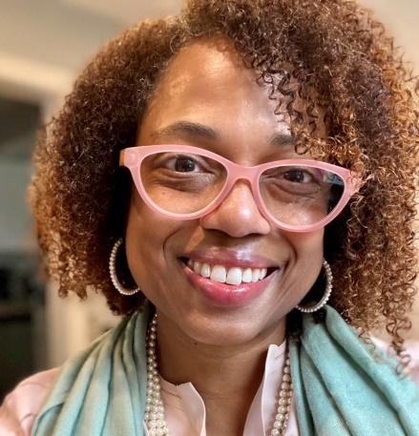
Rev. Melanie Mullen serves as Episcopal Church’s Director of Reconciliation, Justice & Creation Care – charged with bringing the Jesus Movement to the world’s concerns. Before joining the Presiding Bishop’s staff, she was the Downtown Missioner at St. Paul’s Episcopal Church in Richmond, leading a historic southern congregation’s missional, civic, and reconciliation ministries. Before receiving her Masters in Divinity from Virginia Theological Seminary, she studied history as an undergrad at the University of North Carolina, Chapel Hill, NC, and in a graduate program in Africana Women’s Studies at Clark Atlanta University. Melanie worked in campaign fundraising and development, raising more than $10 million for leadership PACs, the Congressional Black Caucus, and US Congressional and gubernatorial races from Louisiana to Connecticut; and she served as Development Associate for the National Law Center on Homelessness and Poverty, with a focus on poverty advocacy.
Mullen currently serves as the Downtown Missioner at St. Paul’s Episcopal Church in Richmond. Prior to that she was the Interim Missioner for Youth Ministries for the Episcopal Diocese of Washington; Assistant Director of Community for Camp Richmond Hill; and the Director of Communications and Development for Lutheran Volunteer Corps. During her years in the nation’s capital, she also worked in campaign fundraising and development and raised more than $10 million for leadership PACs, the Congressional Black Caucus, and US Congressional and gubernatorial races from Louisiana to Connecticut; and she served as Development Associate for the National Law Center on Homelessness and Poverty, with a focus on poverty advocacy.
Rev. Mullen is a graduate of Virginia Theological Seminary with a Masters of Divinity; and the University of North Carolina, Chapel Hill, NC, with a Bachelors in History.

Regina Q. Banks
DIRECTOR, LUTHERAN OFFICE OF PUBLIC POLICY- CALIFORNIA
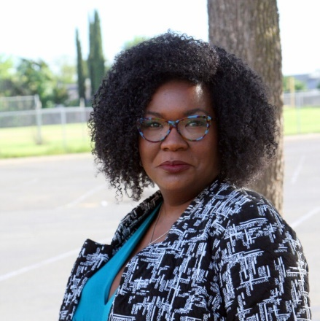
Regina currently serves as the Director of the Lutheran Office of Public Policy- California where she facilitates, coordinates and directs members of the Lutheran Church in their state and local advocacy centered upon: 1) ending childhood poverty in California, 2) adequate, safe and affordable housing for all, 3) water justice, and 4) care for our immigrant and migrant siblings.
Ms. Banks is a proud alumna of Valparaiso University School of Law, where she was a Jurist Scholar, and Lincoln University of MO. She states, “I look forward to the marriage of my analytical and advocacy skills with my deep and abiding faith. I admire the work of the LOPP-CA and will work diligently on their behalf for policies that strengthen people and families and honor the majesty of God’s creation.”
She has worked in policy and budget analysis as both the Legislative Director for a Southern California Assembly member and Legislative Director for consumer interests for several years. She has first-hand experience of the systemic and systematic use of power systems to reinforce discriminatory and damaging status quos and she has spent her professional career fighting against them.
Regina’s work has been deeply fulfilling, but also exhausting. These societal ills are all important and compete with one another for time, energy and funding. Regina is running for Area 1 Trustee for Elk Grove Unified School District because she’s concerned about equity issues in her district – especially amidst the pandemic, ending the school to prison pipeline and closing the achievement gap. Where there are gaps in the systems, our schools are expected to pick up the slack. While EGUSD has weathered many of these issues better than others, it has not been immune. Regina intends to be a voice for all students and families as well as teachers and school staff in Area 1.

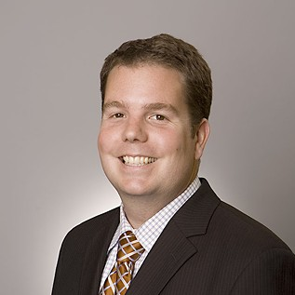
Blake Rocap
LEGISLATIVE COUNCIL, AVOW
Blake is a healthcare lawyer with a focus on public policy and Reproductive Justice. He has worked with the Texas Legislature for almost a decade. He is longtime board member and volunteer attorney for Jane’s Due Process, representing abused teenagers in judicial bypass proceedings. Blake grew up attending public schools in San Angelo, before moving to Austin to attend the University of Texas. He earned his BA in American Studies with a minor in Government before returning to West Texas to attend the Texas Tech School of Law on a full Regent's Scholarship. While in law school he was a founding board member of the Student Public Interest Initiative, the social director of the Board of Barristers and a member of the institution's curriculum committee. Blake and his wife live in central Austin with their two daughters and chocolate lab, Arnold.

John Hill
INTERIM GENERAL SECRETARY AT THE BOARD OF CHURCH AND SOCIETY
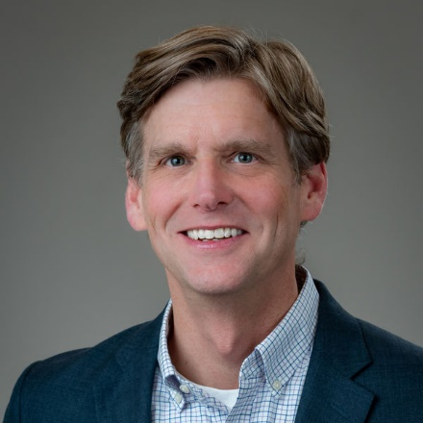
John is the interim general secretary at the Board of Church and Society where he directs the agency’s vision, mission and mandate for witness and action on issues of human well-being, justice, peace and the integrity of creation. He oversees responses to critical social issues, facilitates the church’s legislative advocacy, and coordinates its priorities for the U.S. Congress and United Nations Ministry.
Before serving as the Interim General Secretary, John was the Deputy General Secretary at Church and Society for eight years leading all programmatic efforts for the agency’s advocacy, organizing, education and engagement mission on Capitol Hill and across the world. Prior to joining Church and Society, John studied international affairs at the University of Virginia. Upon graduation, he was awarded a fellowship to teach politics in England. He then served as a legislative aide in the U.S. House of Representatives before working as a lobbyist in the private sector. “Since joining Church and Society in 2002, I have enjoyed engaging United Methodists as we seek to better align our daily living with our faith,” he said.
Committed to teaching Sunday School, John is often inspired and energized by the children he instructs each Sunday at Foundry United Methodist Church.

Diana Forester
DIRECTOR OF HEALTH POLICY, TEXANS CARE FOR CHILDREN
Diana Forester joined Texans Care for Children as the Director of Health Policy in 2022. In that role, she leads the organization’s work with the Texas Legislature, state agencies, and stakeholders to support health equity, improve access to health care for moms and kids, and more. Diana is frequently quoted in the media on maternal health care policy, the health insurance implications of the Public Health Emergency, children’s health coverage, and more.
Before joining Texans Care for Children, Diana spent over a decade with the Texas Health and Human Services Commission (HHSC), worked for Chair Lois Kolkhorst on the Texas House Public Health Committee in 2013, served as a case manager at Foundation Communities, and worked in the legislative war room at AT&T headquarters.
During her time as HHSC, Diana served in a number of senior roles. Most recently, as a Maternal Health Research Analyst, she was the maternal health lead for Medicaid quality initiatives. In previous positions at HHSC, Diana worked on ACA implementation projects, monitored the Medicaid and CHIP state plan amendments that deal with eligibility, and oversaw the Forms process for all of Access & Eligibility Services, among other responsibilities.
Diana has a Masters of Public Health from the Texas A&M University School of Rural Public Health and a Bachelor’s degree in Sociology from the University of Texas at Austin.
Diana loves registering people to vote, paddle boarding, and taking her pop-up trailer to state and national parks with her husband and two young kids.

Abiodun Oluyomi, Ph.D.
ASSISTANT PROFESSOR, BAYLOR COLLEGE OF MEDICINE

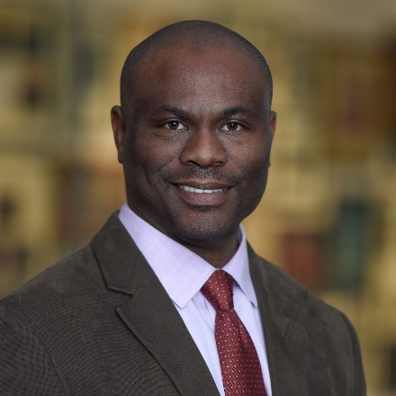
Dr. Abiodun Oluyomi received his PhD from the University of Texas Health Science Center in Houston, specializing in Environmental Health Science and Spatial Epidemiology. His professional interests include environmental health, spatial epidemiology, social determinants of health, and disaster research including global climate change.
Dr. Oluyomi’s broad-based scientific background and professional experience cut across multiple fields including environmental health sciences, environmental design and management, epidemiology, geographic information system, and data analytics. In his research, he examines associations between environmental stressors and health by using exposure assessment methods that emphasize the significance of place. He assesses how stressor-disease relationships pathways operate at varying spatial scales, how social forces create disparities in the distribution of environmental stressors, and how moderating factors influence observed stressor-disease relationships.

Ricardo Martinez
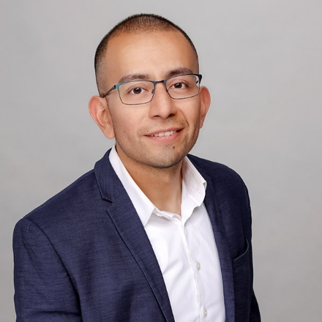
CEO, EQUALITY TEXAS
Ricardo joined Equality Texas as its CEO in December of 2019 following a national search. Ricardo is a first generation immigrant from Mexico who grew up in Brooklyn, New York and attended public schools through high school. He was the second person of his immediate family to graduate high school and the first to earn a Bachelor’s and Master’s degree. Ricardo was called to a career as an advocate for equity and inclusion after participating in a program called Council for Unity in junior high school. Council for Unity focused on leadership development, self-expression, mediation, conflict resolution, mindfulness and advocacy. Ricardo credits his participation with helping him to uncover his passion and life purpose for mission-based work.
After post-secondary education, Ricardo amassed seventeen years of nonprofit fundraising, organizing, advocacy, and leadership experience with organizations like PENCIL, Summer Search, GLSEN, and Stand for Children. Most recently at Stand for Children, Ricardo lead a national organizing and constituent engagement effort for five years. Immediately prior to his tenure at Stand for Children, he spent several years with GLSEN; initially as Senior Manager of Field Services on the national team in NYC and later as the President of the Phoenix Chapter. Under Ricardo’s leadership, GLSEN Phoenix was an instrumental coalition partner in overturning Arizona’s “no promo homo” law, which prohibited K-12 schools from including LGBTQ representation, content, and history in their curriculum.
Ricardo has an undergraduate degree from Stony Brook University, and a master’s degree in nonprofit management from The New School in New York City. He was honored by the Obama Administration as an emerging LGBTQ Leader in 2012 and recently awarded the Stony Brook University’s 40 Under 40 award for the impact he has had in Civil Service and Activism since graduating from the university.

Rev. Mel Caraway
INTERFAITH CLIMATE CONSULTANT, TEXAS IMPACT/TEXAS INTERFAITH CENTER FOR PUBLIC POLICY
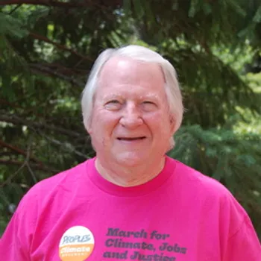
Mel Caraway is a retired United Methodist pastor living in McKinney, Texas. He is the Past President of the Board of Directors of Texas Impact/Texas Interfaith Power and Light. He is certified as an Emergency Responder by the United Methodist Committee on Relief, and has responded to multiple disasters including hurricanes, tornadoes, and floods. He is a member of the Steering Committee of the United Methodist Creation Justice Movement, the Coordinator of the North Texas Conference Green Team, and is commissioned by the General Board of Global Ministries as an EarthKeeper. He is frequently called on to testify before legislative hearings and the EPA on matters related to Creation Justice and the intersection of the climate crisis and faith.

Terri Burke
EXECUTIVE DIRECTOR, THE IMMUNIZATION PARTNERSHIP
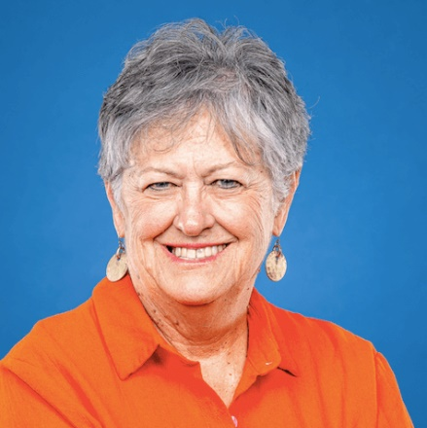
Terri Burke was the executive director of the ACLU of Texas for nearly 13 years. Prior to that she had a long career as a journalist, first as a reporter at Texas newspapers and later as a political and investigative reporter and eventually as a senior editor at The Hartford (Ct.) Courant. A native Texan, her career included stints as a senior editor at The Dallas Morning News, the Austin American-Statesman and Albuquerque Tribune before becoming editor in chief of the Abilene Reporter-News in Texas. An industry leader in recruiting news staffs that looked like the communities they served, Burke consulted with newspapers large and small about how to do likewise. Her tenure at the ACLU of Texas was marked by a dramatic increase in both budget and staff sizes, as well as recruiting and retaining one of the most diverse nonprofit staffs in the state. She continues to work in the nonprofit sector.
She served as president of the boards of the Texas, and later New Mexico, Associated Press Managing Editors associations. She was an adjunct professor of journalism at the University of Texas at Austin and a lecturer at the American Press Institute. She served as president of the board of the Nonprofit Management Center of West Texas and on the boards of the nonprofit Day Nursery of Abilene and Planned Parenthood of West Texas. Burke served on the Quality of Place Committee of the Greater Houston Partnership and she is a member of the Philosophical Society of Texas.

Bee Moorhead, MPA
EXECUTIVE DIRECTOR, TEXAS IMPACT
Bee Moorhead has been Executive Director of Texas Impact and its sister organization, the Texas Impact Foundation, since 2000. Under Bee’s leadership, Texas Impact and the Texas Impact Foundation are among the most respected interfaith networks in the country. Texas Impact regularly mobilizes tens of thousands of Texans from across a spectrum of faith traditions to advocate for policies that support vulnerable people, local communities, and a livable planet. The Texas Impact Foundation produces timely policy research and analysis, and delivers innovative policy and advocacy education through publications, events, and extensive online multimedia offerings.
Bee’s policy expertise includes a wide range of issues including health and human services, climate, migration, public budgets, and civic engagement. She has served on numerous state agency working groups and task forces on topics ranging from nursing homes to hurricane response. She is a credentialed observer to the United Nations climate policy negotiations process; in that capacity, she has attended the United Nations Framework Convention on Climate Change’s annual Conference of the Parties every year since 2015. She is a registered lobbyist with the State of Texas. Her government experience includes 8 years as a senior fiscal policy analyst for the Texas Comptroller of Public Accounts.
Bee holds a Bachelor of Arts in Costume Design from the University of Texas at Austin, and a Master of Public Affairs from the Lyndon Baines Johnson School of Public Affairs at the University of Texas at Austin. She has completed coursework at Austin Presbyterian Theological Seminary and is a trained Mentor for former Vice-President Al Gore’s Climate Reality Project.
Since 2012, Bee has been an adjunct faculty member at Austin Presbyterian Theological Seminary where she co-leads a senior-level course in Faith and Public Policy. She also has taught a version of this curriculum as a required government course for undergraduates. Through her leadership, Texas Impact partners with seminaries and universities throughout Texas to offer internships and other learning opportunities to Texas higher education students. She is a sought-after lecturer and presenter at conferences, religious gatherings, and in a variety of educational settings. Her writing has appeared in major Texas newspapers and denominational publications.
An ordained ruling elder in the Presbyterian Church (USA), Bee currently serves on the Session of University Presbyterian Church in Austin, where she has been a member since 1983. She is a leader in her neighborhood association and serves as a poll worker for Travis County. She serves as the trustee of her family’s historic farm, Locust Grove, in Meigs County, Ohio, and serves on the board of the United Church of Christ Cornerstone Fund.
Bee is married to Robert Moorhead, a longtime staff member for the PBS series Austin City Limits, the longest-running music program in television history. The Moorheads have three grown children and one grandchild.

Joshua Houston
ADVOCACY DIRECTOR, TEXAS IMPACT
Josh is an attorney and registered lobbyist whose experience in state government spans three decades. His responsibilities include legislative strategy; legal and policy research; direct lobbying; media relations; and grassroots strategy. A policy generalist, Josh has specific expertise in the policy areas of electric and water utilities, consumer finance, criminal justice, and child welfare policy; as well as election, First Amendment, civil rights, administrative, and nonprofit law.
Before coming to Texas Impact/Texas Interfaith Center in 2010, Josh worked for the Texas House of Representatives during the 81st Legislative Session, and as a legislative consultant for the Texas Baptist Christian Life Commission during the 79th Legislature. He also interned at the Travis County District Attorney’s Office.
He earned his Doctor of Jurisprudence from the University of Texas School of Law in 2010, a Master of Theological Studies from the Candler School of Theology at Emory University in 2007, and a Bachelor of Arts in History with a minor in Philosophy from Texas A&M University in 2004.
A fourth-generation Texan, Josh enjoys standup paddle boarding, exploring Austin’s greenbelts, and strategy games. He is an active member at the First Baptist Church of Austin.

Scott Atnip
ENGAGEMENT DIRECTOR, TEXAS IMPACT
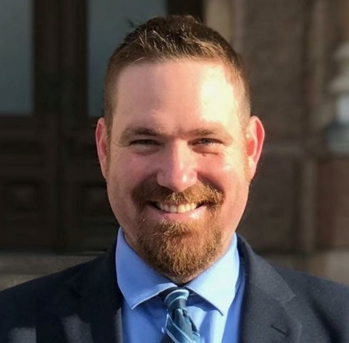
Scott rejoined the Texas Impact staff as Engagement Director in 2012 after a stint as a Texas Impact intern in 2002-2003. Scott connects Texans of faith with opportunities to engage in the policy process through Texas Impact programs like Weekly Witness, Rapid Response, Legislative Engagement Groups and Faith in Democracy. He received his B.A. in Political Science from Sam Houston State University and an M.A. of Public Affairs from the Lyndon Baines Johnson School of Public Affairs at the University of Texas and is a Certified Lay Servant in the United Methodist Church.
In addition to his work with Texas Impact, Scott has spent a lifetime of service in the United Methodist Church. He was elected to the Texas Conference delegation to General Conference in 2012 and 2020 and served as a District Lay Leader and Associate District Lay Leader from 2008-2016. He has served as a Board Member for the General Board of Global Ministries and with U.M. ARMY and JUMMP and at the local church level as Outreach Committee Chair and has received recognitions from district and conference United Methodist Women groups.
Outside of church-work Scott has served as a Board Member for CASA of Walker County and the Walker County Community Development Corporation and previously served as the Executive Director of Huntsville’s Promise, a youth community development non-profit organization.
Scott enjoys traveling the state of Texas for Advocacy Trainings for Texans of faith learning to effectively engage with their elected state representatives. Then he loves to come to spend time with his wife Shannon, a nurse, and his two public school aged children. In his free time, Scott coaches his daughter and son’s youth soccer teams.

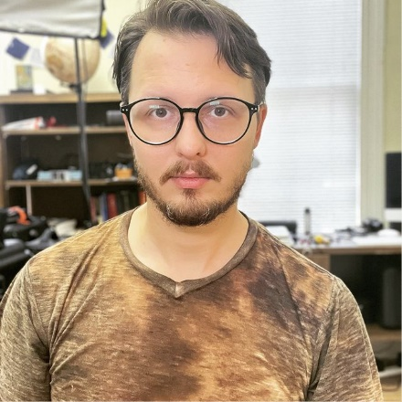
David Vassallo
DIGITAL COMMUNICATIONS MANAGER, TEXAS IMPACT
David joined Texas Impact full time in January 2022 after having worked alongside the team during live events for years. David heads up digital communications including, but not limited to, Texas Impact’s social media pages and YouTube channels. Prior to working with Texas Impact, David managed live event production for several companies in and around the Austin area. Now he brings his production prowess and passion for policy to the table in service of expanding the reach of Texas Impact’s works.
David is a long-time Austin resident and father of three. Both he and his wife, Colleen, are active in their community and participate in organizing for social justice and mutual aid. David is a musician and producer with a deep passion for experimental composition and synthesizers.

Katie Wang, MPA
COMMUNITY MOBILIZATION MANAGER, TEXAS IMPACT
Katie rejoined the Texas Impact staff in 2023 as Community Mobilization Manager in Greater Houston after a stint as an Associate Policy Analyst at Texas Impact in 2015-2016. Katie mobilizes and equips communities of faith in the Greater Houston region to engage with critical state-level policy issues, helping to build knowledge and advocacy skills through policy-focused programming. Prior to her role at Texas Impact, Katie was the Associate Director of Community Engagement at Rice University’s Kinder Institute for Urban Research where she managed community engagement efforts through a partnership-based experiential learning program, a public-facing neighborhood-level data program, and other special projects.
Katie earned Bachelors of Arts in Latin American Studies and Plan II Honors from the University of Texas at Austin and a Master of Public Affairs from the Lyndon Baines Johnson School of Public Affairs at the University of Texas at Austin. In her free time, Katie co-chairs the young professionals organization at Interfaith Ministries for Greater Houston and serves on the board of Culture of Health – Advancing Together (CHAT), a nonprofit organization serving refugee and immigrant communities in Houston’s Gulfton neighborhood. You might also find her getting her hands dirty in her community garden plot, painting, riding her bike along the bayous, and enjoying Houston’s global food scene.

Isa Peterson
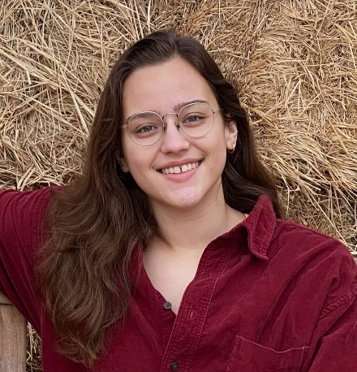
CLIMATE AND ENERGY FELLOW, TEXAS IMPACT
Isabella Peterson is spending a year-long fellowship with Texas Impact through the Evangelical Lutheran Church in America (ELCA). In this fellowship Isabella will experience a year-long transformative experience combining leadership development and faith formation with impactful advocacy engagement. Isabella works to increase Texas Impact’s advocacy network, research and development efforts and represent the equitable values that Texas Impact embodies.
Isabella graduated from The University of Texas at Austin with a B.A. in Government and Sustainability Studies. Before joining Texas Impact she spent her undergraduate years working for environmental nonprofits in Austin, such as Rainforest Partnership and the Shoal Creek Conservancy, advocating for environmental change and urban conservation. Isabella hopes to continue their career focused on the intersection of environmental and social policy during their time with Texas Impact and beyond. Outside of her nonprofit work Isabella loves to garden, visit the gym, and spend time with her family in her hometown of San Antonio, Texas.

Katherine Karbach
NETWORK DEVELOPMENT MANAGER, TEXAS IMPACT
Katherine (Kat) Karbach is our new Network Development Manager. She comes to us from Virginia, where she spent eight years in development and marketing with a nonprofit focused on domestic violence and human trafficking. She’ll be helping us strengthen our communication with our more than 25,000 network members, including answering questions and helping you plug into engagement opportunities.

Heather Malkawi
UNITARIAN UNIVERSALIST JUSTICE FELLOWSHIP, TEXAS IMPACT
Heather Malkawi has recently joined Texas Impact in 2021 as an intern from Austin Presbyterian Theological Seminary. She is dual degree student working on both her Master of Divinity and in the process of applying to The University of Texas for her Master of Science in Social Work.
Heather graduated from the University of Michigan – Flint with a B.A. in Sociology. Before coming to Austin, I spent a few years as a social worker before finding her passion in insurance.
In her free time, she is the parent of two teenagers.

Fabiola Olvera Benitez
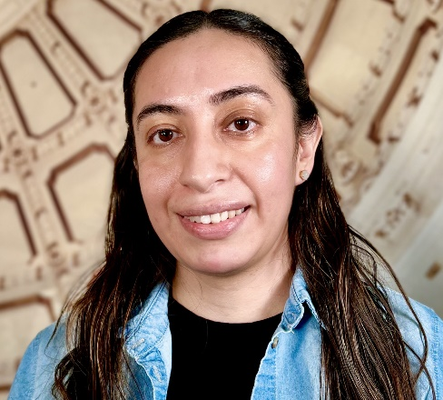
IMMIGRATION EDUCATION AND ADVOCACY MANAGER, TEXAS IMPACT
Fabiola Olvera Benitez is a formerly undocumented, daughter of immigrants, and law school graduate with experience in immigration law. Fabiola earned a J.D. from Northeastern University School of Law and a B.A. from Rhode Island College. Fabiola’s passion for immigration advocacy stems from having both first-hand and professional experience with the immigration legal system.
Fabiola is currently based in the Rio Grande Valley but grew up in Rhode Island and has lived and worked in NYC and Los Angeles. Fabiola is excited about being the new Courts & Ports manager and is ready to continue empowering others to advocate for humane immigration policies.

Bobby Watson
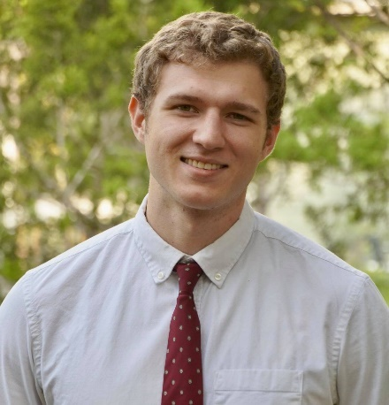
HUMAN RIGHTS AND CIVIC ENGAGEMENT FELLOW, TEXAS IMPACT
Bobby graduated from Trinity University 2021 Cum Laude with a BA in Political Science and minors in Spanish and Russian. He was a recipient of the Benjamin A. Gilman Scholar award for his Russian studies in 2019.
Bobby has over 5 years of work experience with non-profits, such Vamos Ya, a nonprofit that works to provide educational and recreational resources to underserved youth in inner-city, west-side San Antonio, Texas. He is currently working as the Human Rights Fellow at Texas Impact, focusing on policy related to gun violence and immigration.

Becca Edwards
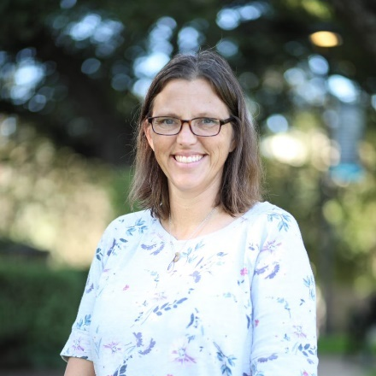
VOLUNTEER, TEXAS IMPACT
Becca Edwards is a senior at Austin Presbyterian Theological Seminary and will graduate in May with a Masters in Divinity. She is chair of the Mercy and Justice committee at First United Methodist Church of Austin and is a certified deacon candidate in the Capital District of the Rio Texas Annual Conference. Prior to seminary, Becca earned a PhD in Wind Science and Engineering at Texas Tech University. She was a visiting assistant professor of physics at Southwestern University in Georgetown, Texas for ten years, teaching engineering, energy, and climate science courses and conducting research in the areas of hydroclimate extremes and air quality. Her current interests include ecotheology, climate justice, and interfaith understanding.
In her free time, Becca enjoys reading, cooking, and spending time outside with her husband and four children.

